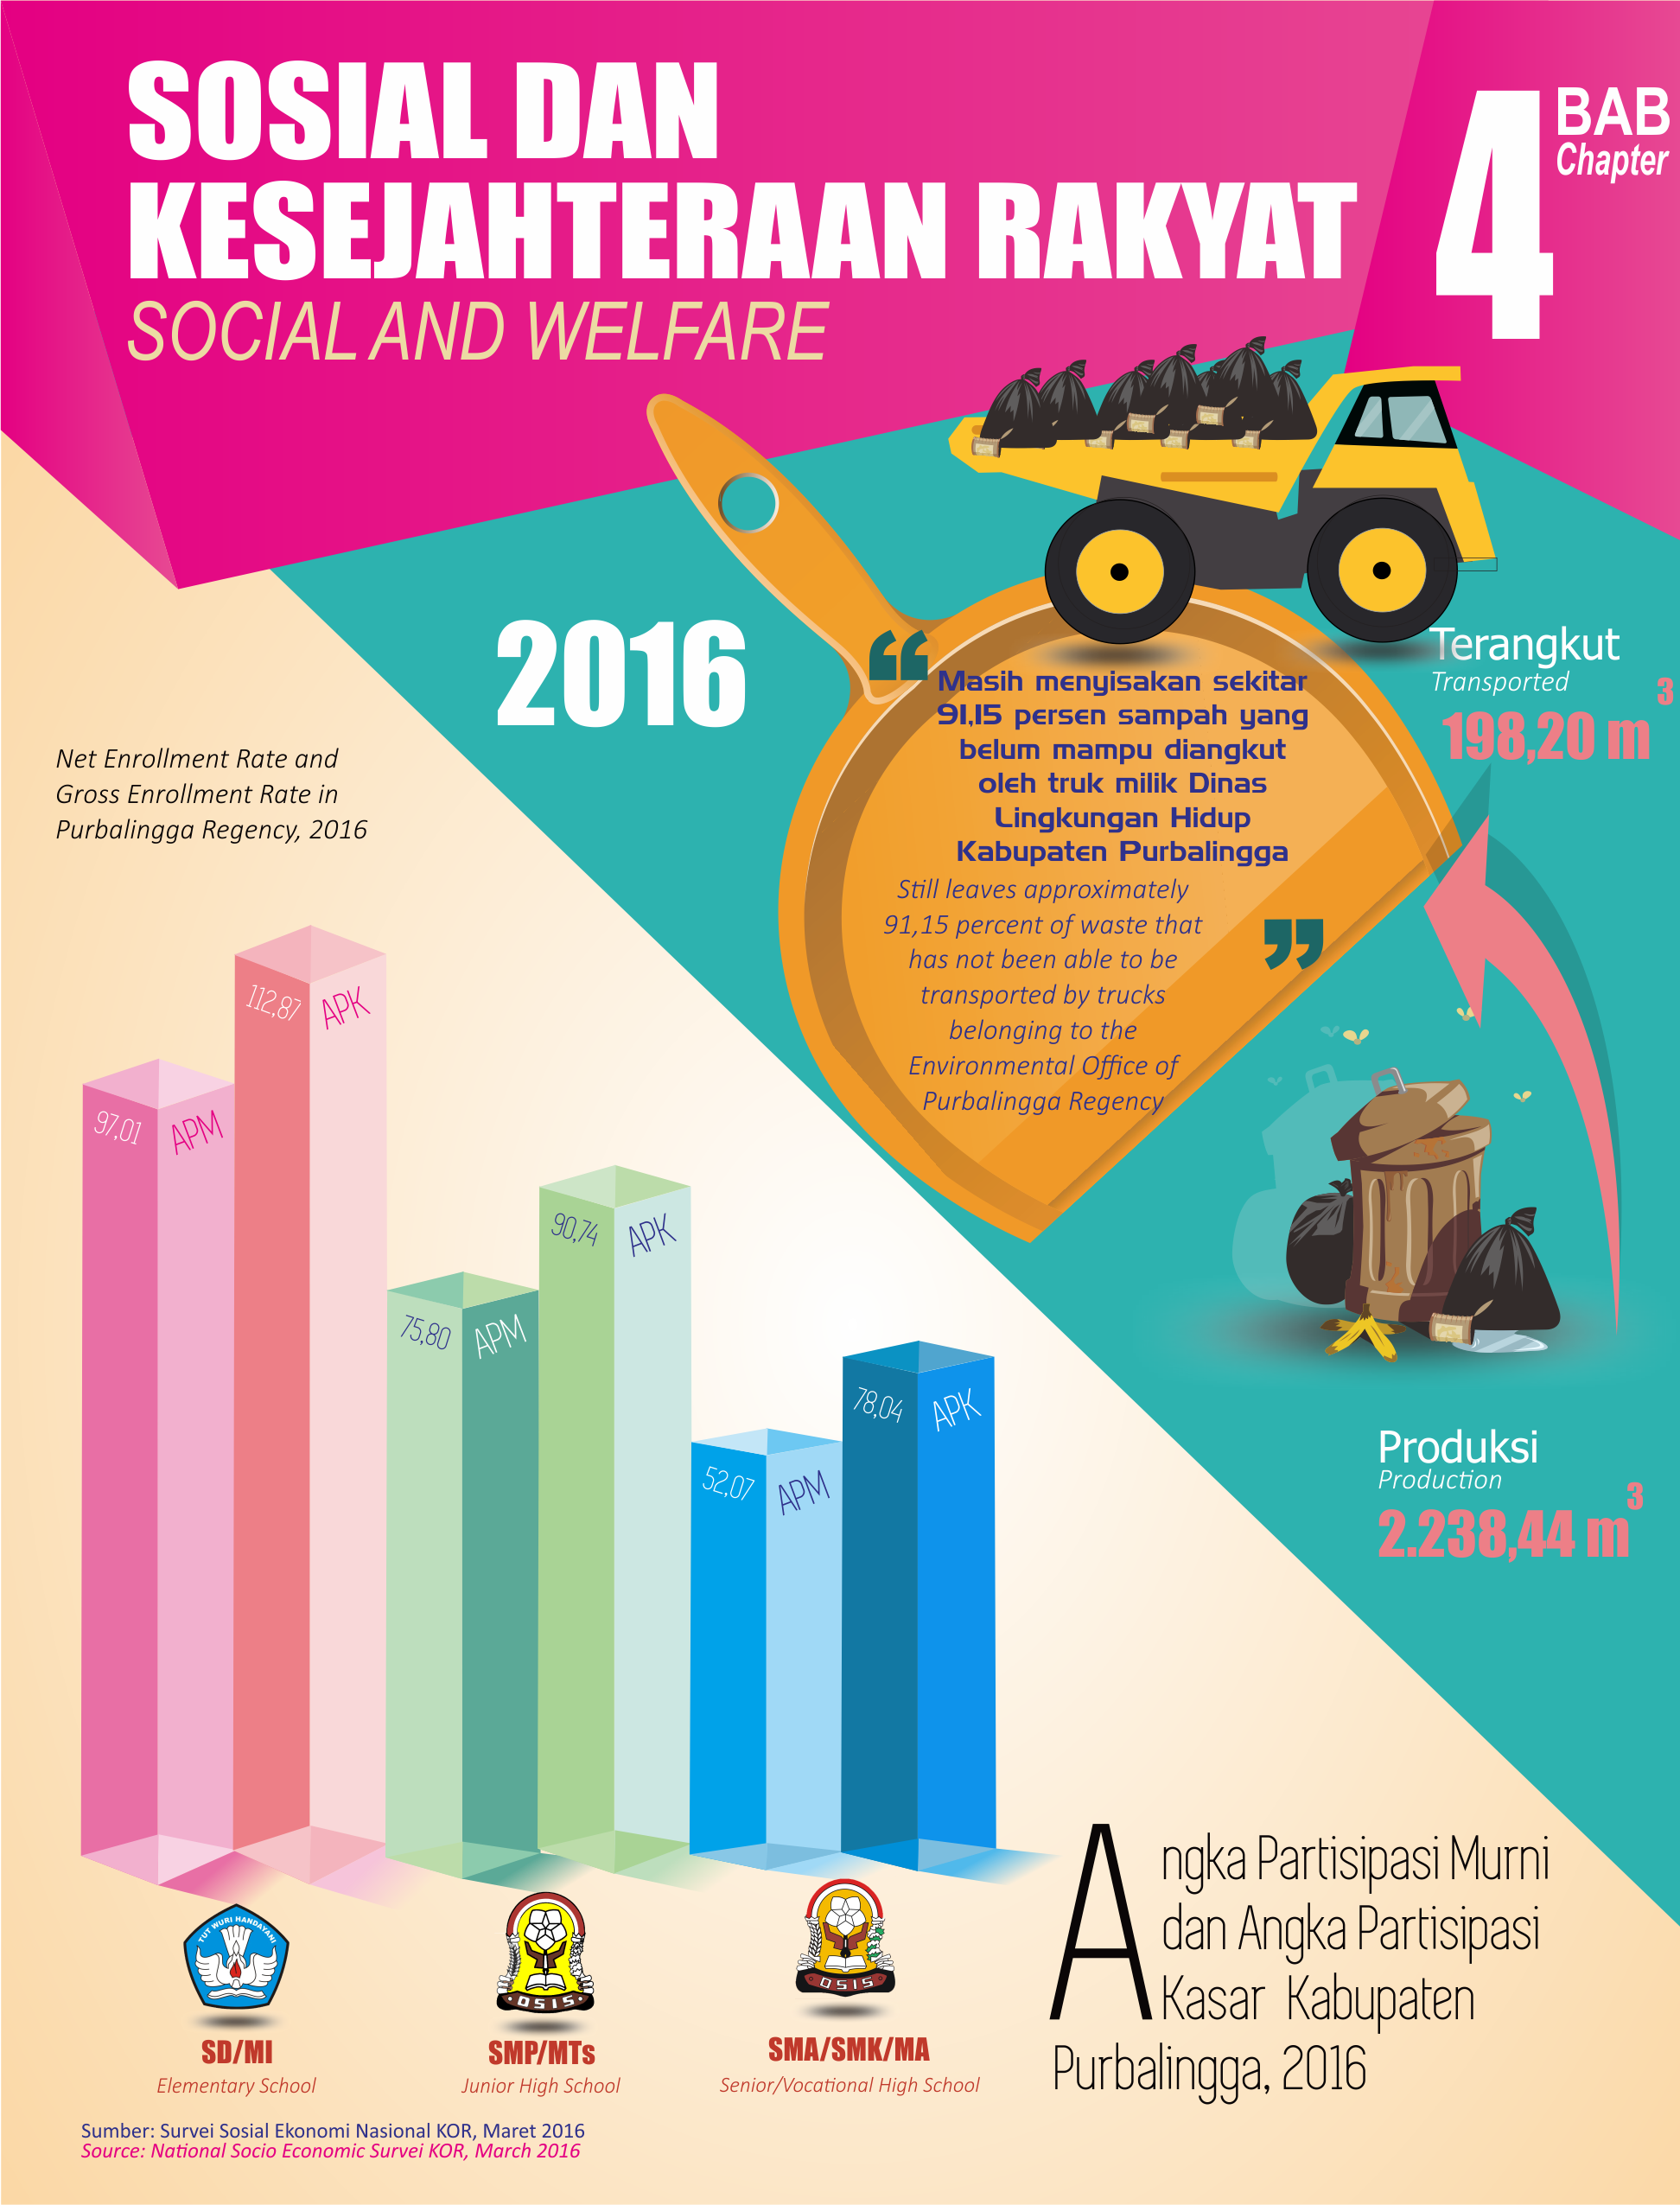

PENJELASAN TEKNIS

1. Tidak/belum pernah sekolah adalah mereka yang tidak pernah/belum pernah terdaftar dan tidak pernah/belum pernah aktif mengikuti pendidikan di suatu jenjang pendidikan formal. Termasuk juga yang tamat/belum tamat taman kanak-kanak tetapi tidak melanjutkan ke sekolah dasar.

2. Masih bersekolah adalah mereka yang terdaftar dan aktif mengikuti pendidikan formal dan nonformal (Paket A, B atau C), baik pendidikan dasar, menengah/pendidikan tinggi. Bagi mahasiswa yang sedang cuti dianggap masih bersekolah.

3. Tidak bersekolah lagi adalah mereka yang pernah terdaftar dan aktif mengikuti pendidikan di suatu jenjang pendidikan formal dan non formal (Paket A, B atau C), tetapi pada saat pencacahan tidak lagi terdaftar dan tidak aktif mengikuti pendidikan.

4. Tamat sekolah adalah menyelesaikan pelajaran yang ditandai dengan lulus ujian akhir pada kelas/tingkat terakhir suatu jenjang pendidikan di sekolah
TECHNICAL NOTES

1. Not/never attending school is someone who has never attended or never been registered in a formal education, such as primary, secondary, and tertiary education. Those who just completed kindergarten are considered as never attended school.

2. Attending school is someone who is currently attending primary, secondary, or tertiary education, including package A, package B, or package C. College student who postpones his/her study is considered as attending school.

3. Not attending school anymore is someone who had enrolled and participated in formal and non-formal education in the past including package A, package B, or package C, but currently does not attend school.

4. Completed particular level of education is someone who has completed particular level of education in private or public school and accepting graduation
negeri maupun swasta dengan mendapatkan tanda tamat belajar/ijazah. Seseorang yang belum mengikuti pelajaran pada kelas tertinggi tetapi telah mengikuti ujian akhir dan lulus dianggap tamat sekolah.

- Rumah Sakit adalah tempat pemeriksaan dan perawatan kesehatan, biasanya berada di bawah pengawasan dokter/tenaga medis, yang melayani penderita yang sakit untuk berobat rawat jalan atau rawat inap.

- Rumah Sakit Bersalin adalah rumah sakit khusus untuk persalinan, dilengkapi pelayanan spesialis pemeriksaan kehamilan, persalinan, rawat inap dan rawat jalan ibu dan

- Puskesmas (Pusat Kesehatan Masyarakat) adalah unit pelaksana teknis dinas kesehatan kabupaten/ kota yang mempunyai fungsi utama sebagai penyelenggara pelayanan kesehatan tingkat pertama.
certificate. Someone who has never attended the highest grade but passed the final exam is considered as completed particular level of education.

- Hospital is a place for health check, usually controlled/supervised by doctors/medical personnel to serve the ill patients to get outpatient or inpatient treatment services.

- Maternity Hospital is a specialized hospital for childbirth, has specialist inspection service to pregnancy, childbirth,

- Public Health Center is technical implementation unit of regency health department that have the primary function as a first-level health care providers.

- Penduduk miskin adalah penduduk yang memiliki rata-rata pengeluaran per kapita per bulan di bawah Garis Kemiskinan.

- Garis Kemiskinan Makanan (GKM) merupakan nilai pengeluaran kebutuhan minimum makanan yang disetarakan dengan 2.100 kkalori per kapita per hari. Garis Kemiskinan Non-Makanan (GKNM) adalah kebutuhan minimum untuk perumahan, sandang, pendidikan, kesehatan, dan kebutuhan dasar lainnya.

- Ukuran Kemiskinan
- Head Count Index (HCI-P₀) adalah persentase penduduk miskin yang berada di bawah Garis Kemiskinan (GK).
- Indeks Kedalaman Kemiskinan (Poverty Gap Index-P₁) merupakan ukuran rata-rata kesenjangan pengeluaran masing-masing penduduk miskin terhadap garis kemiskinan. Semakin tinggi nilai indeks, semakin jauh rata-rata
- A person whose expenditure per capita per month is below the poverty line is considered to be poor.

- The Food Poverty Line refers to the daily minimum requirement of 2,100 kcal per capita per day. The Non-Food Poverty Line refers to the minimum requirement for household necessities for clothing, education, health, and other basic individual needs.

- Poverty Measures
  - Head Count Index (HCI-P0) simply measures the percentage of the population that is counted as poor, often denoted by P0.
b. Poverty Gap Index-P1 measures the extent to which individuals fall below the poverty line (the poverty gaps) as a proportion of the poverty line. Higher value of the index shows that the gap between average expenditure of the poor and the poverty line is wider.
pengeluaran penduduk dari garis kemiskinan.
- Indeks Keparahan Kemiskinan (Poverty Severity Index-P₂) memberikan gambaran mengenai penyebaran pengeluaran di antara penduduk miskin. Semakin tinggi nilai indeks, semakin tinggi ketimpangan pengeluaran di antara penduduk miskin.

c. Poverty Severity Index-P2 describes inequality among the poor. This is simply a weighted sum of poverty gaps (as a proportion of the poverty line), where the weights are the proportionate poverty gaps themselves. Hence, by squaring the poverty gap index, the measure implicitly puts more weight on observations that fall well below the poverty line. Higher value of the index shows that inequality among the poor is higher.

ULASAN

- PENDIDIKAN

Dari catatan Dinas Pendidikan Kabupaten Purbalingga terdapat sekolah TK sebanyak 509 sekolah dengan guru 903 orang, murid 18.207 siswa; SD sebanyak 647 sekolah dengan guru 5.841 orang, murid 100.466 siswa; SLTP sebanyak 114 sekolah dengan guru 2.416 orang, murid 44.895 siswa; SLTA Umum sebanyak 24 sekolah dengan guru 863 orang, murid 10.825 siswa dan SLTA Kejuruan sebanyak 32 sekolah dengan guru 1.583 orang, murid 19.569 siswa.

- SOSIAL LAINNYA

Berdasarkan data dari Dinas Kesehatan Kabupaten Purbalingga, jumlah sarana kesehatan di Kabupaten Purbalingga terdapat rumah sakit 5 buah, rumah bersalin 1 buah, puskesmas 22 buah, pukesmas pembantu 48 buah, puskesmas keliling 22 buah dan apotik 73 buah. Sedangkan jumlah tenaga kesehatan dokter 189 orang, bidan 450 orang dan paramedis lainnya 1.483 orang.

DESCRIPTION
A. EDUCATION
From Purbalingga Regency Education Service Office Report there are Kindergarten as much as 509 schools with 903 teachers, 18.207 pupils. Elementary School as much as 647 schools with 5.841 teachers, 100.466 pupils. Junior High School as much as 114 schools with 2.416 teachers, 44.895 pupils. Senior High School as much as 24 school with 863 teachers, 10.825 pupils and Vocational Senior High School as much as 32 schools with 1.583 teachers, 19.569.

B. OTHER SOCIAL
According to Public Health Purbalingga Regency Service Office, number of health facilities in Purbalingga Regency there are 5 hospitals, 1 maternity hospital, 22 health centers, 48 sub health centers, 22 mobile health center and 73 pharmacies. While, number of medicals 189 doctors, 450 midwifes and 1.483 other paramedics.

Gambar 4.  Picture 4. | Jumlah Sekolah, Siswa dan Guru Tingkat SD, SLTP, SLTA dan SMK, 2016/2017  Number of School, Pupils and Teacher at Level Elementary School, Junior High School, Senior High School and Vocationaly Senior High School, 2016/2017

  - PENDIDIKAN/EDUCATION

  - KESEHATAN/HEALTH

  - KRIMINALITAS/CRIME
  - AGAMA/RELIGION

  - LINGKUNGAN/ENVIRONMENT

  - KEMISKINAN/POVERTY

  - SOSIAL LAINNYA/OTHER SOCIAL AFFAIRS

